

# Topic: Application of Blockchain in Healthcare System

This week, we worked on implementing the structure and architecture outlined in the DigiArogya project diagram. Additionally, we integrated two new features for better understanding of the application with the help of Alok Sir and Rakhi Mam. According to the last meeting we are trying to develop an inter connected system between patient and Pharmacy and patient laboratory workflow.

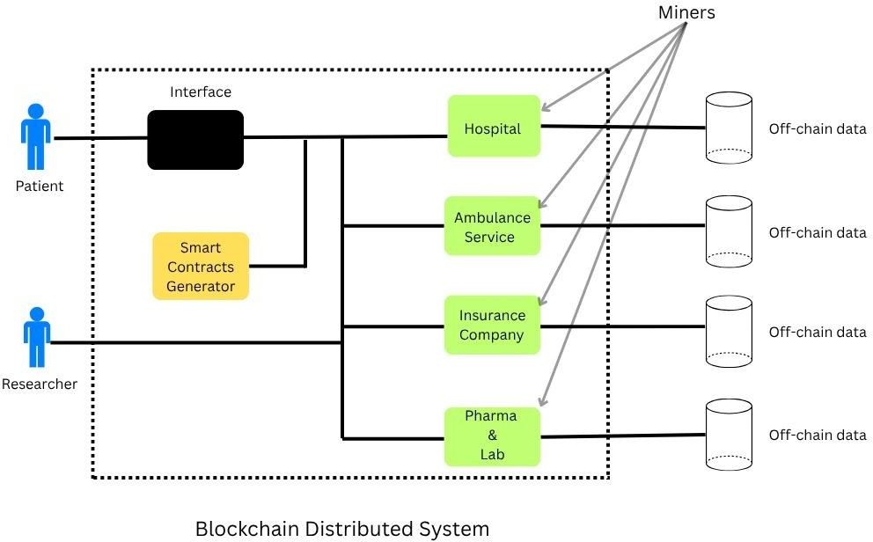

1. We added a register and dashboard for each of these modules.

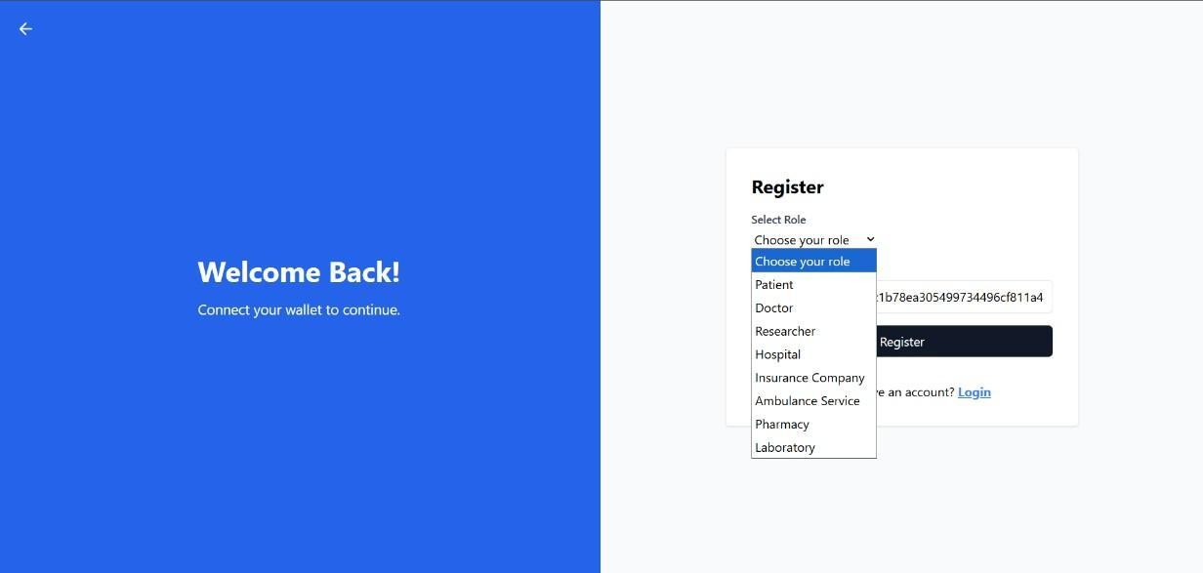

2. Emergency Dashboard

The Emergency Ambulance Access Dashboardto automatically detect emergency situations and grant access accordingly; it also allows users to manually request ambulance services, and once utilized, the service usage is reflected in the Patient Dashboard interface.

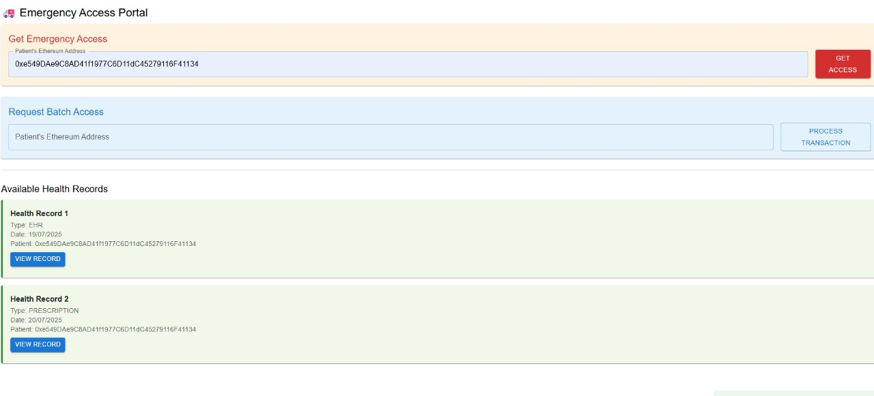

Fig – Emergency access portal

1. 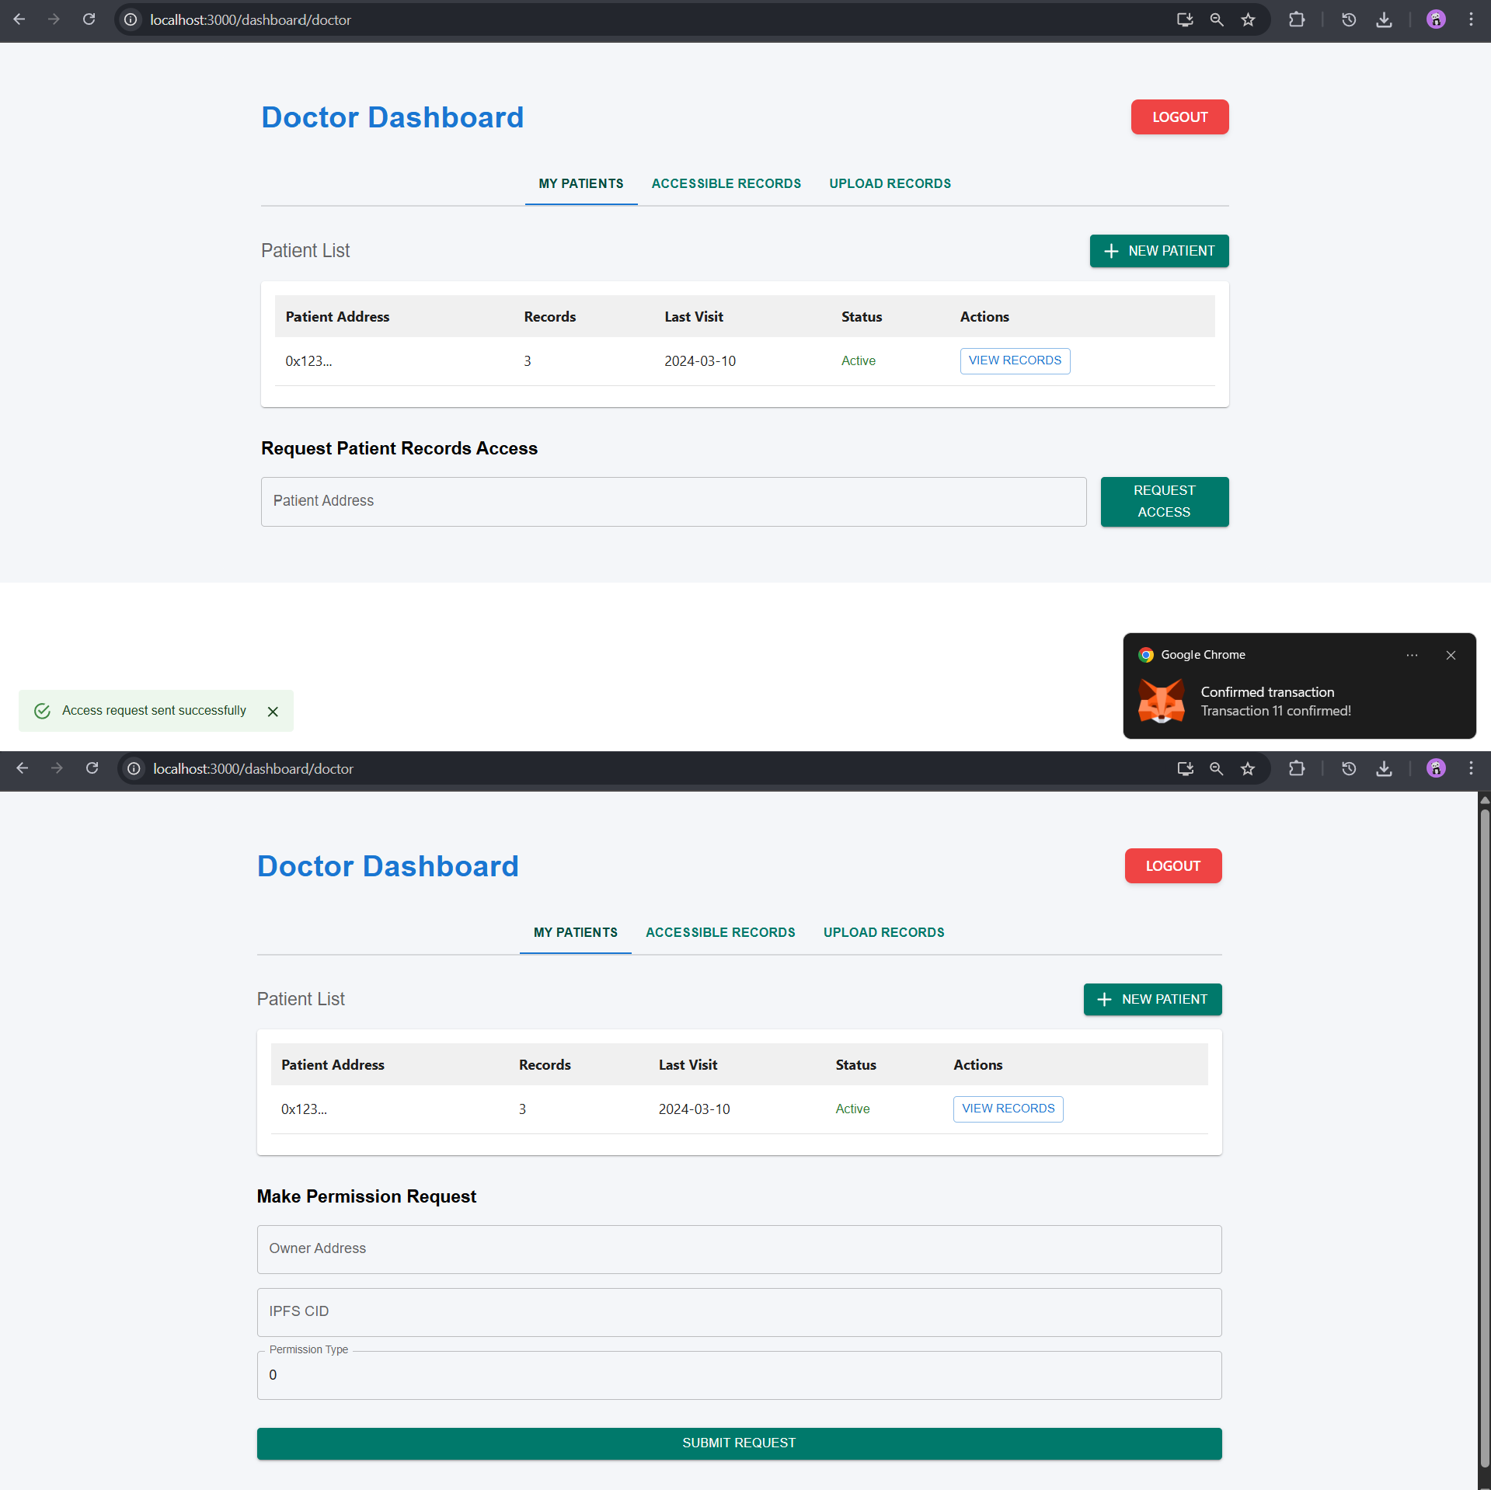Simplified the Doctor Dashboard by allowing the doctor to access all of a patient's records with a single request instead of raising request for each entry and added an expiry date for the permissions.

**Fig. Previous Doctor Dashboard**

**Fig. New Simplified Doctor Dashboard**

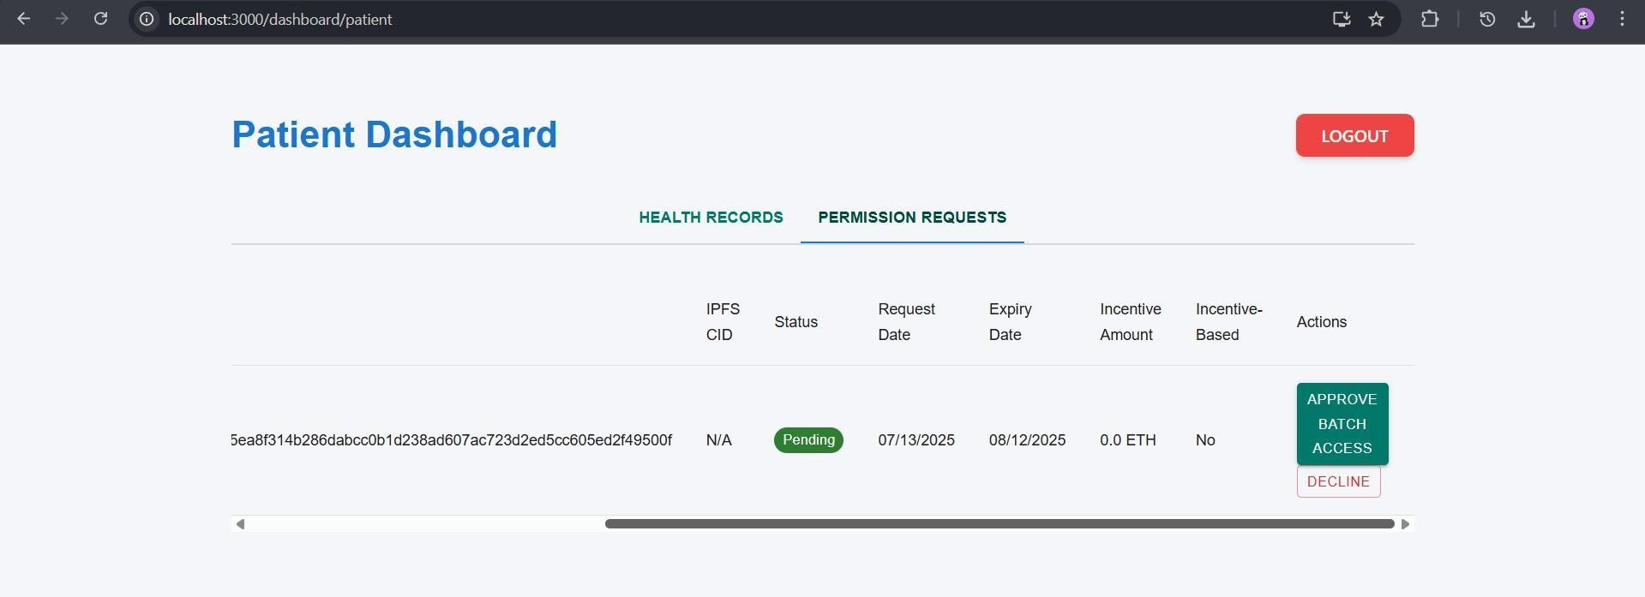

**Fig. Batch Access Request for all of Patient’s record at once**

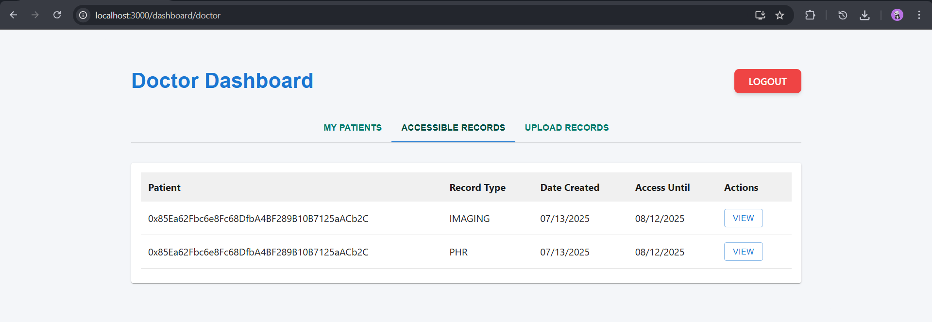

**Fig. All uploaded records being accessible at once**

1. Simplified the Hospital Dashboard to manage availability of Beds, Doctors and hospital related services such as pharmacy, laboratory, emergency services, etc.

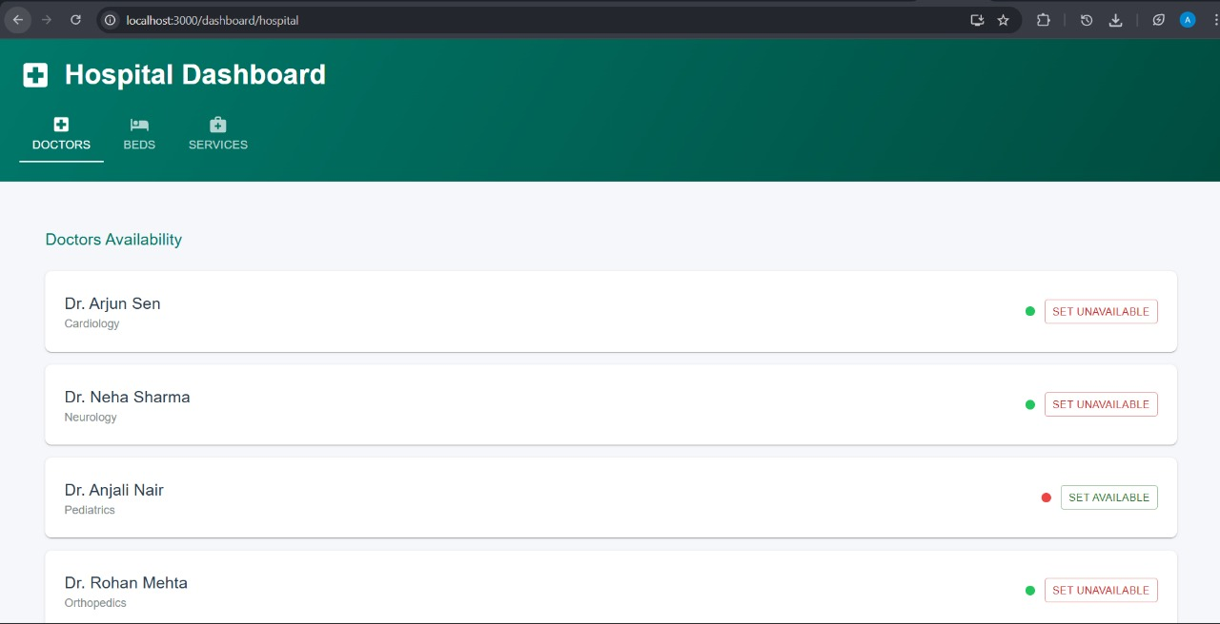

**Fig. Hospital Module to manage doctor’s availability**

# 

**Fig. Hospital Module to manage beds availability**

# 

# Fig. Hospital Module to manage hospital related services

### **Laboratory Dashboard**

The Laboratory Dashboard is currently under development, with core functionalities like a clean interface and the ability to add patients already implemented; upcoming features include fetching prescriptions from the Patient Dashboard, classifying lab results by test types (e.g., MRI, CT scan, blood sugar), and ensuring that uploaded results are clearly visible on the Patient Dashboard.

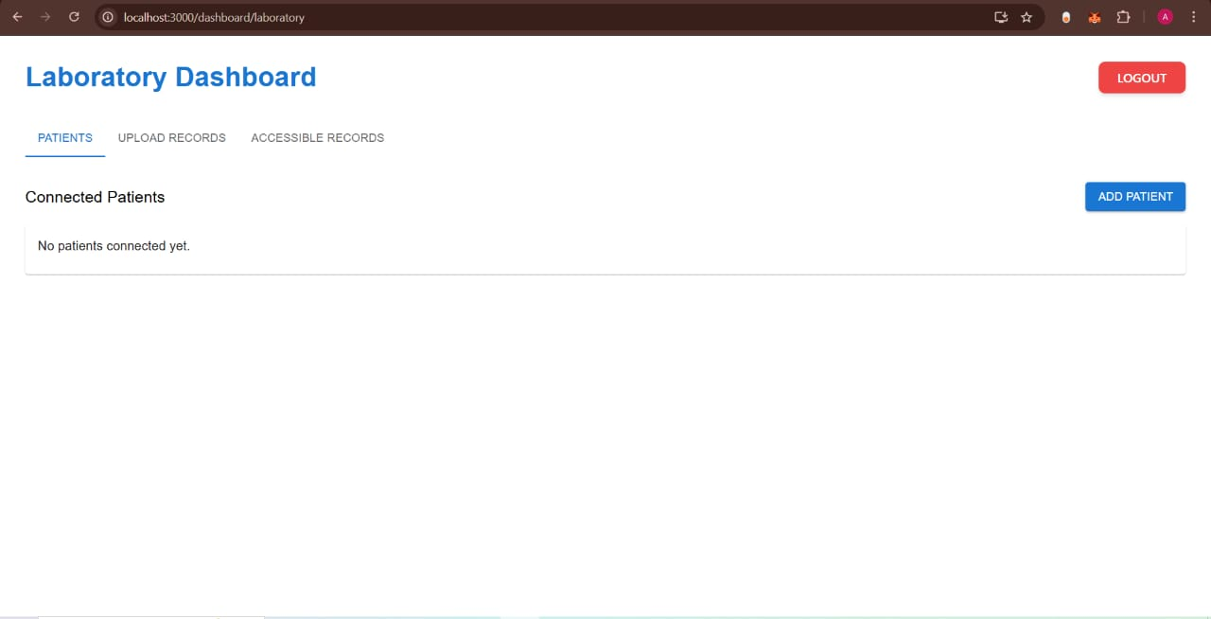

#### Fig. Added functionality to **add new patients** to the lab database

#### **Functionalities in Progress**

Once a lab report is uploaded by the laboratory, it will be instantly visible on the Patient Dashboard. Additionally, authorized roles—including patients, doctors, and researchers—will have the ability to assign lab tests. To ensure transparency and data integrity, all test results and their timestamps will be securely logged using blockchain technology.

# 

# **Fig. Upload lab reports** by the laboratory dashboard

# Pharmacy Dashboard

Functionality has been added to the Pharmacy Module, enabling patients to upload prescriptions, which are then processed by the pharmacy with the corresponding bill generated and recorded on the public blockchain. Likewise, the Laboratory Module now allows patients, doctors, and researchers to assign lab tests, which are conducted by the laboratory, resulting in the automatic generation of lab records for the patient. 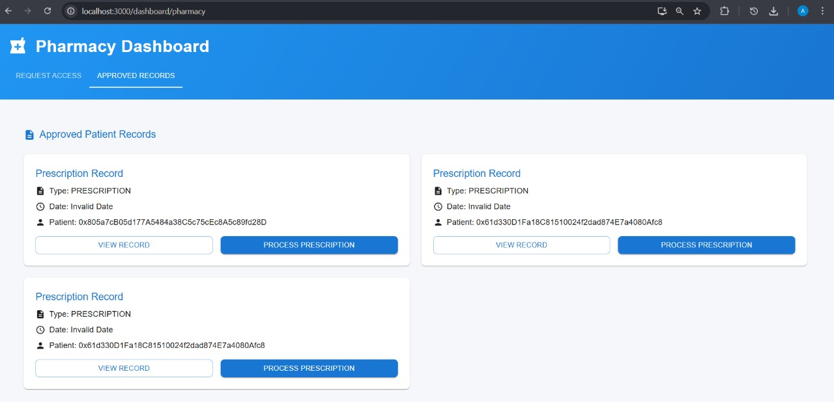

# **Fig. Accessing Patients Prescription on Pharmacy Dashboard**

**Submitted by:**

* 1. **Pappu Yadav**

**Bachelor of Technology (B.Tech) in Computer Science Arka Jain University, Jamshedpur**

* 1. **Gaurav Kumar Pandey**

**Bachelor of Technology (B.Tech) in Computer Science Arka Jain University, Jamshedpur**

* 1. **Singh Preet**

**Bachelor of Technology (B.Tech) in Computer Science Arka Jain University, Jamshedpur**

* 1. **Tushar Kumar Das**

**Bachelor of Technology (B.Tech) in Computer Science Arka Jain University, Jamshedpur**

* 1. **Parmod Nayak**

**Bachelor of Technology (B.Tech) in Computer Science Arka Jain University, Jamshedpur**

* 1. **Amar Das**

**Bachelor of Technology (B.Tech) in Computer Science Arka Jain University, Jamshedpur**

* 1. **Avishek Kumar**

**Bachelor of Technology (B.Tech) in Computer Science Arka Jain University, Jamshedpur**

* 1. **Kaushal Jha**

**Bachelor of Technology (B.Tech) in Computer Science Arka Jain University, Jamshedpur**

**Submitted to:**

**Dr. Dinesh Kumar**

**Department of Computer Science & Engineering**

**National Institute of Technology Jamshedpur (NIT Jamshedpur)**